Important Recycling Update to share with janitorial staff

Keep Recycling Loose – No Plastic Bags & No Bagged Recyclables!

Team,

As you’ve probably noticed, we’ve implemented a handful of improvements to our recycling program. One of the biggest changes that we’ve made is eliminating plastic bags and liners from all recycling bins.

## Why Does this Matter?

When our material arrives at the local recycling plant, it goes through an automated sorting process. Recyclables must be loose (not in a bag) in order to make their way through the sorting equipment. Plastic bags cause many problems at the recycling plant as they get wrapped around sorting equipment and must be manually cut out of gears and screens. This poses a safety risk for workers and makes recycling inefficient and costly.

## How You Can Help!

1. Please DO NOT line recycling bins with plastic bags or liners. Only clean and dry materials should be recycled, therefore deskside, breakroom and all other recycling bins should remain clean.
2. Make sure that all recyclables you place in the recycling dumpster/compactor located outside/in the loading dock, etc. are loose – no bagged recyclables!

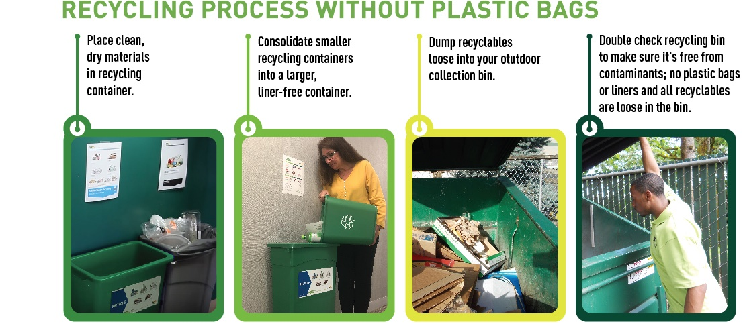

Your role is key to making our recycling program a success! If you happen to notice any recycling bins around the office that contain liquid, food or other non-accepted material, please let me know so that we can provide additional employee training and feedback.

Thank you for your help!

NAME