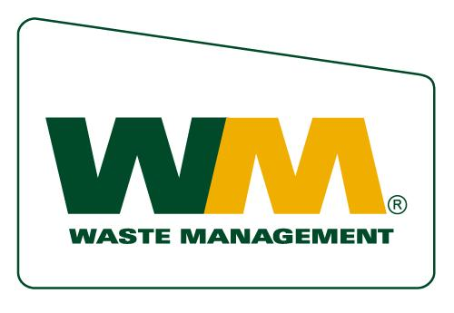

WASTE MANAGEMENT'S PHILOSOPHY OF GIVING
As the leading provider of comprehensive waste and environmental services in North America, Waste Management is committed to being a good steward of the environment and to making communities safer, cleaner and better places to live and work. We provide a variety of resources to our local partners, such as product and financial support, and volunteers. Our employees are dedicated to helping keep our communities clean, green, and vibrant. It's what we do.
Waste Management's business model is to deliver outstanding service and value to its stakeholders, including its customers, employees, investors and community partners.
Our community outreach program is founded on the same principles as our business model and specifically focuses on innovation, service, value and partnership within the communities we serve. We expect our community partners to develop creative solutions to meet pressing needs, to provide services and programs that add value, and to have a positive impact in the community. Given the nature of our business, and as a leader in environmental stewardship, we give priority to nonprofit organizations that focus on protecting and improving the environment, and promoting environmental education.
GIVING GUIDELINES
Programs
At Waste Management, we strive to be a trusted and valued community partner and to positively impact our communities through resourceful and green business practices. The Company's Charitable Contributions program focuses on those communities in which we serve.
The following guidelines outline the programs that Waste Management is most likely to support.
1. Environment
The environment affects all aspects of our lives, from the air we breathe, to the way we power our homes, to the parklands in which we play. Waste Management is committed to helping provide renewal resources to reduce our dependence on fossil fuels, and to conserving and maintaining wetlands, wildlife habitats and green spaces for people's enjoyment. Understanding the importance of the environment, Waste Management supports organizations and programs that preserve and /or enhance natural resources.
2. Environmental Education
The key to ensuring the preservation of the environment is teaching children about the importance of protecting it and acting in an environmentally responsible manner. To this end, Waste Management prefers to support environmental education programs targeted at elementary, middle and high school students. This includes environmental and science related projects, science fairs, Earth Day projects and others.
3. Community
Waste Management is committed to enhancing our communities through programs that help make them cleaner, and better places to live. Local Waste Management facilities are proactive in identifying charities located in the immediate community that they serve and in many cases may have predetermined which organizations they will be supporting that year.
WM Preferences
The Waste Management Charitable Contributions program provides support to organizations that have been approved by the IRS as a 501(c)3 charity and public organizations where any donations requested will be used exclusively for public purposes. We target our support to specific projects or programs that enhance the scope of services offered by an organization. WM prefers not to financially support operating costs, capital campaigns, or multi-year requests. Preference is also given to organizations, which have a broad base of funders and employee involvement.
Eligibity and Restrictions
The Waste Management Charitable Contributions program does not fund:
- Requests from organizations without a 501(c)3 tax-exempt status or do not use funds received exclusively for public purposes - please note that Waste Management rarely provides contributions to social services, arts, and health related organizations.
- Individuals
- Religious organizations unless the project benefits the community, such as a soup kitchen that is housed in a church
- Political candidates or lobbying organizations
- Organizations with a limited constituency, such as fraternal, labor or veteran's groups
- Endowments or foundations
- Travel by groups or individuals
- Anti-business groups
- Organizations that discriminate on the basis of race, color, religion, or gender

WM Charitable Contributions Application Procedures
Nonprofit organizations interested in submitting an application to Waste Management for financial, in-kind or product donations should complete an application and mail to designated person on Registration Form.

Only complete applications will be considered, if they meet the guidelines outlined and provide all the following supporting information:

- Name, address and telephone number of the organization
- Contact person and title
- Background information on the organization including history, mission, activities, and programs
- Copy of the IRS exemption letter verifying 501(c)(3) tax-exempt status
- Current operating budget and sources of income
- List of names and professional affiliations of directors and trustees (where available)

Proposals should include the following information regarding the particular program for which funding is being sought

- Purpose and objectives of the program
- Needs being addressed
- Plan of action and time frame
- Total funding required
- The amount requested
- How the project's success will be determined/measured and how results will be communicated
- Specific ways Waste Management will be recognized
Applications are accepted year round and are reviewed on a continuous basis.
Requests funded in any one year are not assured of future funding. If renewed funding is desired, the organization should submit an additional application.
Applications and requests for information should be directed to:

Community Relations Department
Waste Management of Antelope Valley
P.O. Box 4040
Palmdale, CA 93590-4040

