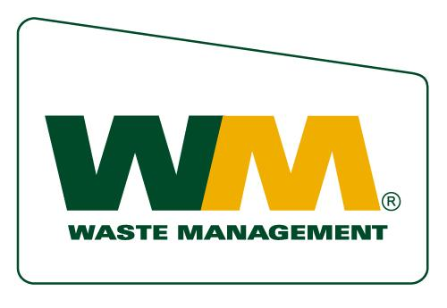
Waste Management of Antelope Valley
P.O. Box 4040
Palmdale, CA 93590
(661) 947-7197
(661) 223-3446 Fax

Non Profit Organizations

Required: 60 DAYS NOTICE PRIOR TO EVENT DATE

CRITERIA FOR GIVING

Applicants MUST adhere to the following:
1. Submit request in writing to WM 60 days prior to date of the event. This includes:

a. Charitable contributions
b. Donations
- In Kind services (for example, waste removal, trash bins, etc.)

2. Letter to council member(s) or member of the Board of Supervisors thanking WM for their assistance.

3. If requested, representatives from the organization must attend a public meeting to support WM as a good community partner.

4. Organization must be willing to publicize the contribution from WM, including articles in internal newsletters or any other internal communications, with photos that include WM staff and recipients when applicable.

- Representatives of the organization must be willing to discuss the charitable contribution and community partnership with media

6. All donated services provided by WM must occur within the Antelope Valley

7. Organization must allow WM to use the organization’s name, logo and images

8. Organization must publicly acknowledge the contribution (ie, WM banners at the event, permanent WM signs at the ballpark, radio, press)

9. Unincorporated County areas must have Waste Management trash service

___________________________ ___________________________________
Signature Date

___________________________ ___________________________________
Title Organization

