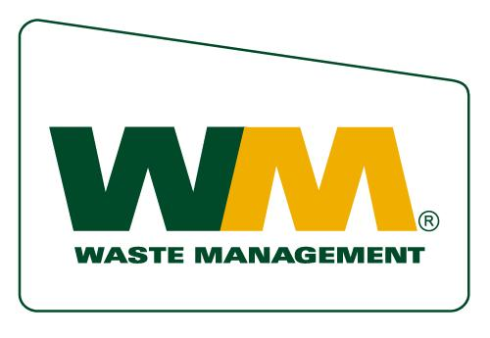

Waste Management Charitable Giving Application

Organizations requesting consideration for a monetary or in-kind donation must submit a typed or hand-written application. E-mail or telephone solicitations will not be considered. You may use as much space as needed to provide the requested information. Incomplete applications will be returned to the sender.

Organization Information

Does your organization have a 501(c) 3 designation form? □ Yes □ No

Are funds for your organization used exclusively for public purposes?

□ Yes □ No

Would any funding for this request:

- Only benefit an individual □ Yes □ No

2 Help promote a particular faith? □ Yes □ No

3 Support any political candidates or lobbying organizations? □ Yes □ No

4 Support an organization with a limited constituency, such as fraternal, labor or veteran’s groups □ Yes □ No

- Support endowments or foundations □ Yes □ No

- Support travel by groups or individuals □ Yes □ No

- Support anti-business groups □ Yes □ No

- Does your organization discriminate on the basis of race, color, religion, or gender? □ Yes □ No

If you responded yes to questions 1-8 and/or if your organization does not use funds received exclusively for public purposes, WM will not be able to provide funding for your organization. If no to questions 1-8, please continue to fill out the registration form on the following page.

CHARITABLE CONTRIBUTION REGISTRATION FORM

Organization Name: |  |  |  |  |  | Tax ID & Designation:
Street Address
City, State, Zip |  |  |  |  |  | Phone:
Contact Name: |  |  |  |  |  | Contact Phone:
Contact Title: |  |  |  |  |  | Contact Fax:
Contact E-mail
NAME OF EVENT: |  |  |  |  |  | EVENT DATE:
TYPE OF CONTRIBUTION DESIRED: |  |  |  | Check below
 |  |  | Charitable Contribution: |  | Amount Requesting: |  | $
 |  |  | Donation: Gift Certificate, landfill vouchers__________________
 |  |  | In Kind Services: trash service_____________________________

Briefly provide the charity’s background information including history and purpose:

Provide the organization’s current operating budget:

If applicable, provide the of names and professional affiliations of directors and trustees (mayor, city council, etc.)

Is a WM employee or executive involved with your organization? If yes, please provide their name

Program/Project Information

Explain the purpose and objectives of the program for which your organization is seeking funding:

Which of the following areas does your program address?

- Environment □ Environmental Education □ Other:

Provide the program/project’s plan of action and period:

What is the total funding required?

Describe how the project’s success will be determined/measured:

Is there anything else you would like us to know as we review the application?

________________________________________________________
Signature of Requester

Date: _________________________________________________

Applications are accepted at any time and reviewed by the Charitable Giving Committee. Telephone or e-mail solicitations will not be accepted.

Applications funded in any one year are not guaranteed future funding. Requests need to be submitted annually.

Non-profit organizations interested in submitting an application to Waste Management of Antelope Valley for monetary, in-kind or product donations should complete an application and send to:

Community Relations Department
Waste Management of Antelope Valley
P.O. Box 4040
Palmdale, CA 93590-4040

