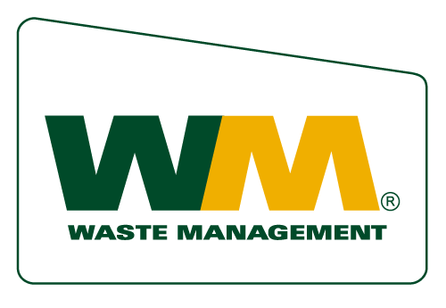

News Release

Media Contacts:

Jennifer Andrews
Waste Management
PH: (619) 890-4698
jandrews@wm.com

Christine Flowers-Ewing
Keep California Beautiful
PH: (916) 368-9301
cflowers@cleanca.org

Waste Management Grants Keep California Beautiful $10,000

CARLSBAD, CALIF, Dec. 2, 2008 – Waste Management today announced its donation of $10,000 to Keep California Beautiful, the non-profit organization dedicated to resource conservation and waste minimization in California. The grant was part of Waste Management’s Think Green® Community Improvement Grants, a nationwide effort that encourages local solutions to improve community relations.

Keep California Beautiful was awarded the grant for its work with the 2009 Carlsbad Marathon supporting the “Only My Feet Hit the Ground” campaign they established at the 2008 event. This campaign encourages event participants to be personally responsible for managing their trash and recyclables along the course while achieving their personal record for time. The nearly 2,000 volunteers for the race could never actually get all the litter picked up the day of the race if every runner and spectator littered the course with discarded food and drink containers.

The inaugural program developed by Keep California Beautiful was highly successful, with over 700 of the 10,000 runners signing the Eco Runner Pledge before the race. The city staff and event organizers were pleased with the results because the streets and roadways were cleaner after the event than before. Last year the race diverted over 57 percent of the overall waste generated. This year Keep California Beautiful will be working with the event organizers to help improve the recycling plan and increase source reduction efforts at the event.

“We are grateful to Waste Management for their generous donation and their vision to work with local organizations to initiate community involvement in improving our environments,” said Christine Flowers-Ewing, executive director of Keep California Beautiful.

“We are pleased to provide this grant to Keep California Beautiful as they work to make the Carlsbad Marathon even greener next year,’ said Ken Ryan, district manager of Waste Management of Carlsbad. “The plan to take the event to the highest level of sustainability is in synch with our goals as an organization, and as a service provider,” he added.

Waste Management is partnering with Keep America Beautiful (KAB) for the third year of the Think Green grants program. More than 575 local KAB affiliates were challenged to present proposals for ambitious projects representing a wide array of stewardship, community outreach and educational projects.

About Keep California Beautiful

Keep California Beautiful works to ignite individuals, state and local governments, communities, and corporate organizational responsibility through strategic initiatives and volunteer action to preserve and protect California’s beautiful natural resources for generations to come. Keep California Beautiful’s goals are to educate and communicate to inspire action by developing source reduction and resource conservation awareness programs. Through public education, outreach, and partnership opportunities, Keep California Beautiful develops and conducts litter prevention campaigns with celebrities such as World Champion Skateboarder Tony Hawk, and Five Time Triple Crown Surfer Sunny Garcia with the message Don't Trash California, encouraging youngsters to make a difference by signing a pledge not to litter and to recycle. Keep California Beautiful provides local community support through the KAB Local Affiliates/Proud Community Program and Great American Cleanup.TM

For more information visit http://www.cleanca.org/

About Waste Management

Waste Management Carlsbad has 103 employees who perform jobs including waste/recycling collector and driver, vehicle maintenance or container maintenance technician and buyback center administrator, in addition to jobs based at the office. The facility provides waste and recycling collection in the cities of Carlsbad, Del Mar, Solana Beach and portions of unincorporated San Diego County.

For more information about Waste Management, visit http://northcounty.wm.com.

Waste Management, based in Houston, Texas, is the leading provider of comprehensive waste management services in North America. Our subsidiaries provide collection, transfer, recycling and resource recovery, and disposal services. We are also a leading developer, operator and owner of waste-to-energy and landfill gas-to-energy facilities in the United States. Our customers include residential, commercial, industrial, and municipal customers throughout North America.

# # #

