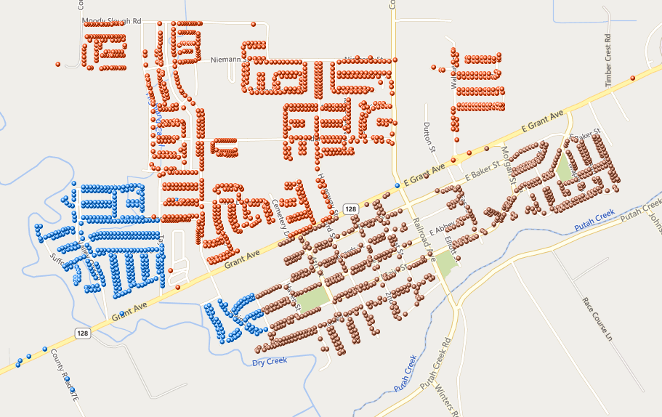

# Thursday

# Friday

# Wednesday